**Gits**

**Git is the version control system**

**Version control is software that tracks and manages changes to file**

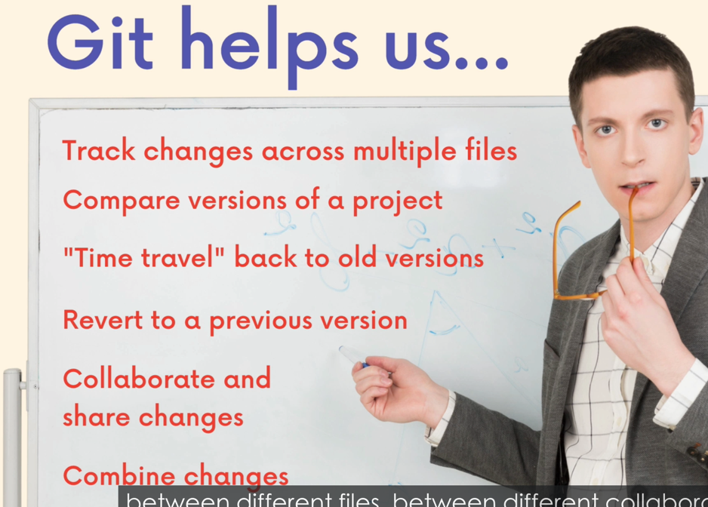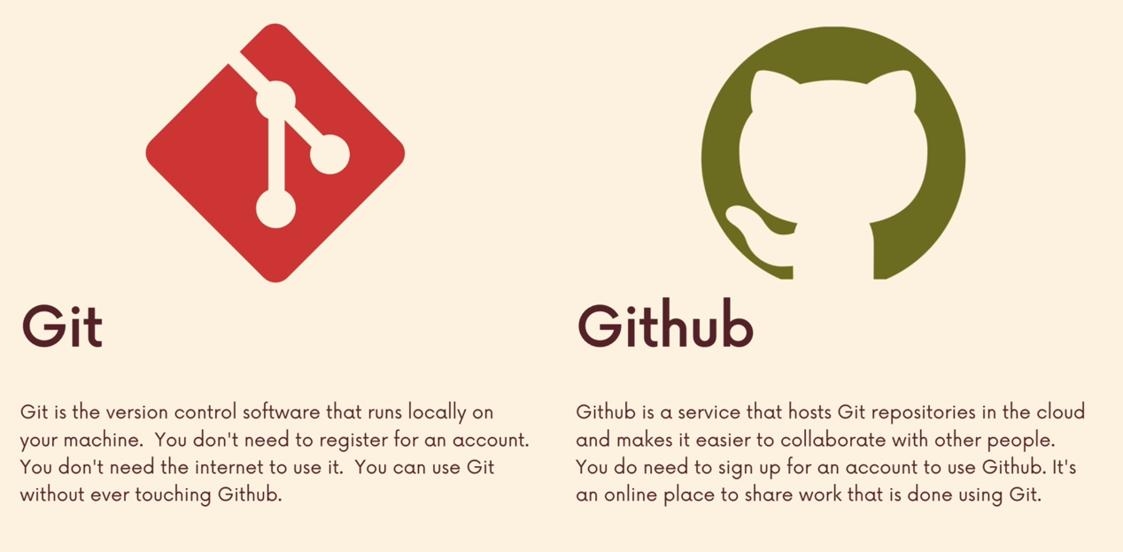

**Check version: git –version**

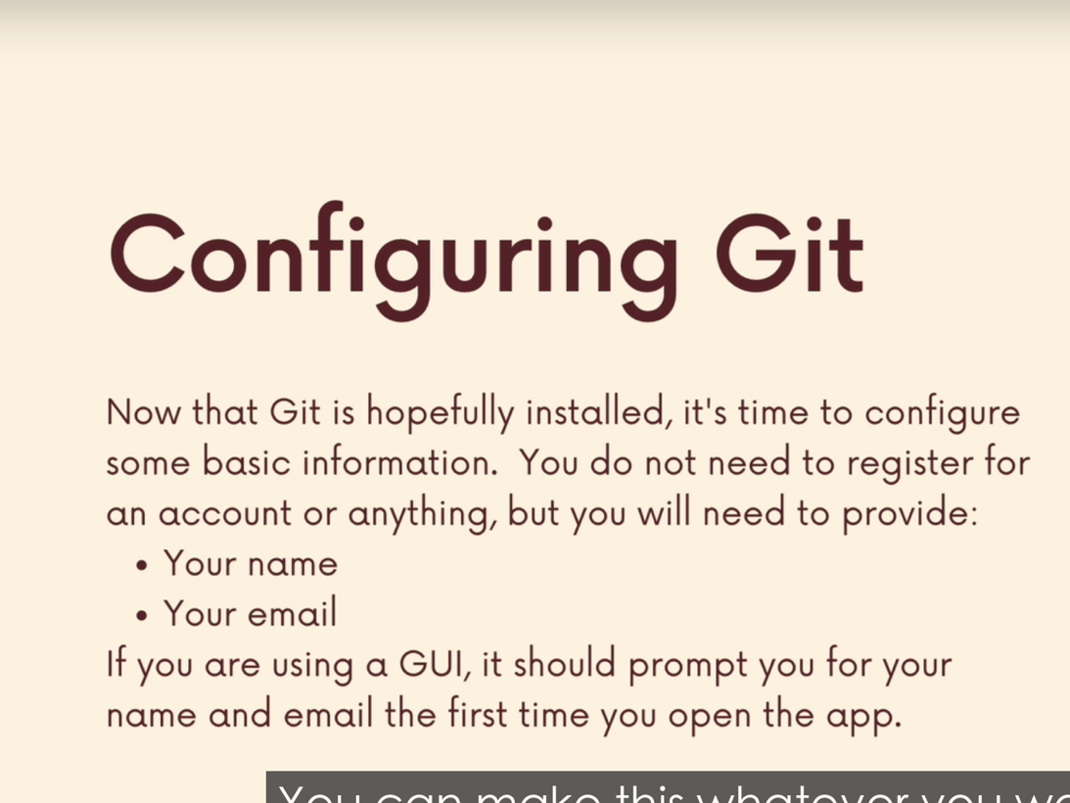

**set username:**

git config --global user.name “yourname”

**check the username, email**

git config user.name

git config user.email

**set email**

git config --global user.email lp1dxing@gmail.com

**config default editor**

reference: https://git-scm.com/book/en/v2/Appendix-C%3A-Git-Commands-Setup-and-Config

**for vscode :**

git config --global core.editor "code --wait"

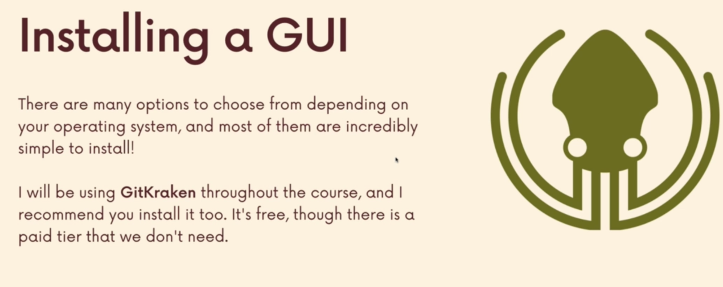

**Terminal crash course**

1. **Navigation**

**List the contents of a folder or of the current directory**

Ls

**List all includes hidden files**

Ls -a

Open up in Finder on a Mac

Open .

List the files in a folder

Ls folder

List the folder in a folder

Ls folder/folder

Open a folder

Open folder

Print out the current location

Pwd

Change directory, move around

Cd folder

Move backward

Cd ..

1. **File and folder creation**

Create a file

Touch file

Eg. Touch purple.js yellow.py …

Create a file inside a folder

Eg. Touch Desktop/Tafe/assignment1.html

Make a directory

Mkdir directory

1. **Deleting**

Rm will delete files, it permanently removes!

Delete folder

Rm -rf

**Core git commands**

1. **What is repo (repository)**

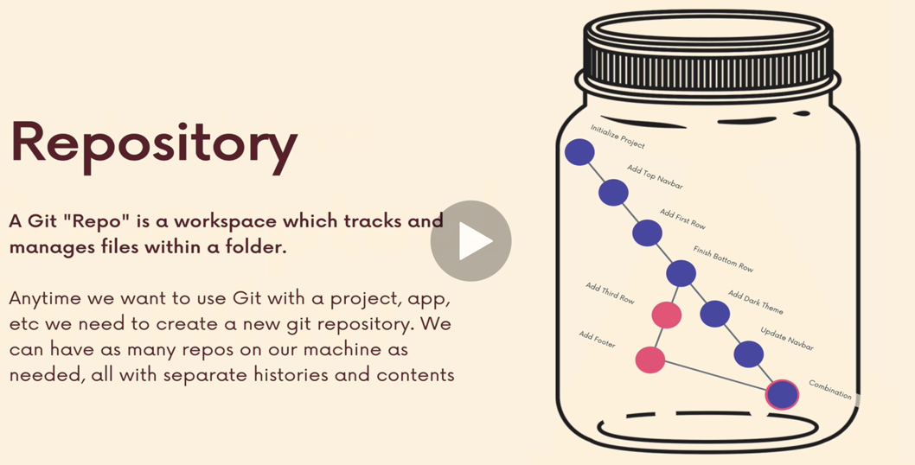

**Git tracks a directory (project folder) and its all nested subdirectories and files**

**DO not init a repo inside of a repo, because nested files and folders will be tracked by git. So before running git init, use git status to verify that you are not currently inside of a repo**

1. **Commands**
2. **git status**

gives info on the current status of a git repo and its contents

1. **git init**

create a new empty git repo in a project folder. The created repo is .git

each project directory should have its own repo

1. git commit

git commit is one of checkpoints in a git repo.

Commit is a checkpoint, a snapshot of changes in our repo.

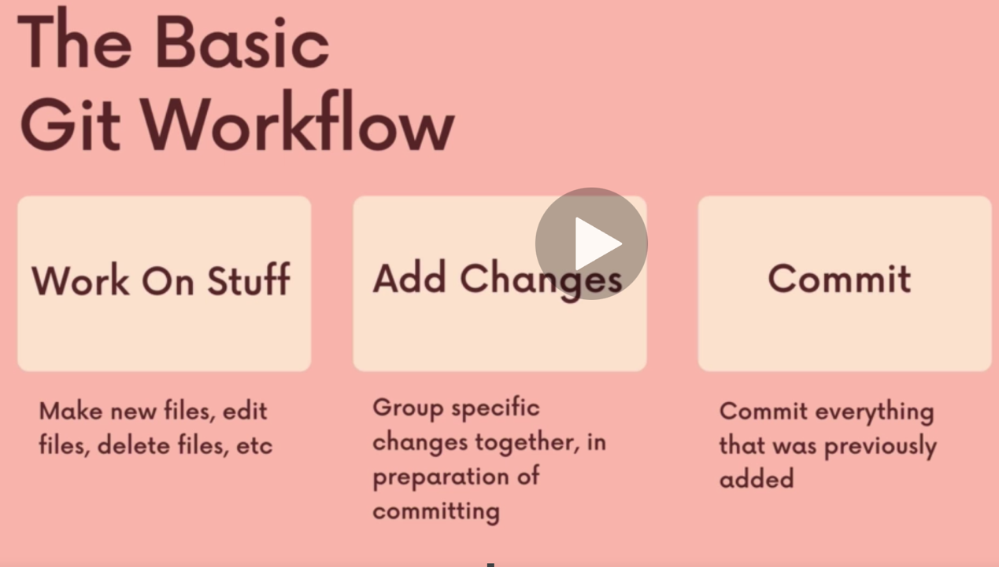

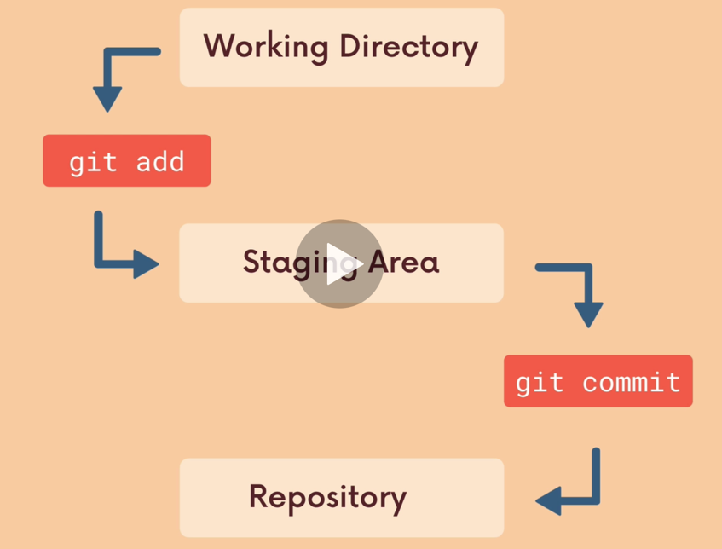

Working directory -- untrack unstaged

Staging area == tracked staged

Repo == committed

After finished work on stuff, firstly git add to track the files (stage the changes), then git commit to update the repo (.git)

Git commit to actually commit changes from the staging area, when making a commit, we need to provide a commit message that summarizes the changes included in the commit

git commit -m “message”

add message when commit, recommend!

Commit message 要用命令式，过去式

如果commit message很长， 要用git commit, 然后在vscode里面输入message。

e.g made changes to xxx file

Git log

Print out the commits

Git log –oneline

Print out brief commit msg

git log --all --decorate --oneline –graph

graph view of the log history

Git add .

Stage all changes at once

When possible, a commit should encompass a single feature, change or fix. Try to keep each commit focused on a single thing.

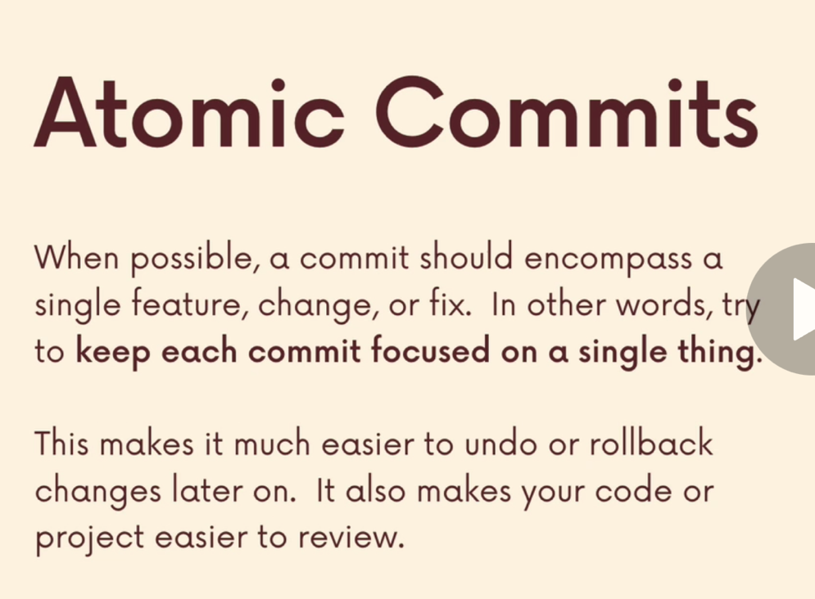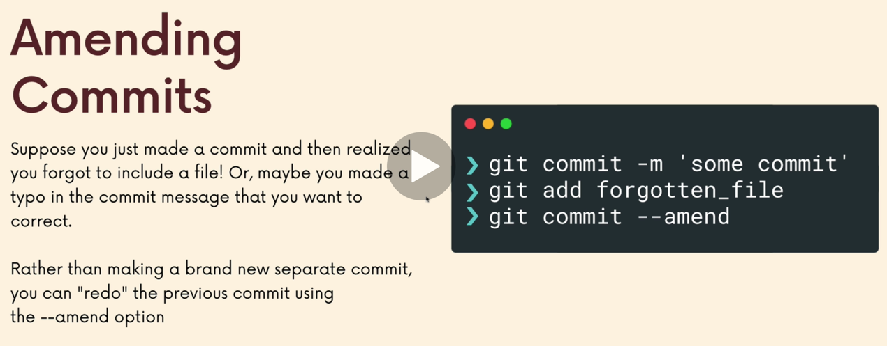

Git commit –amend

Redo the previous commit, for cases when you have typo in the previous commit msg, or you forgot to add files in the last commit

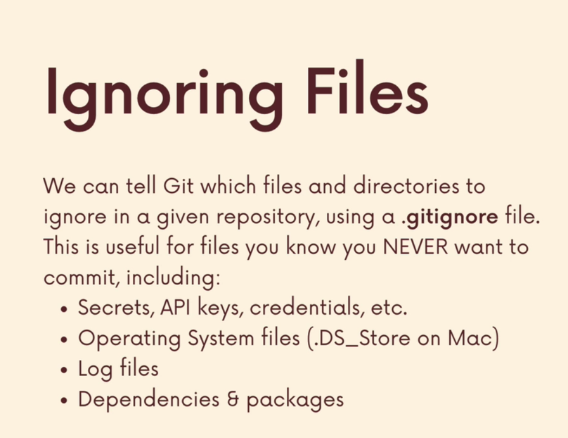

.gitignore file

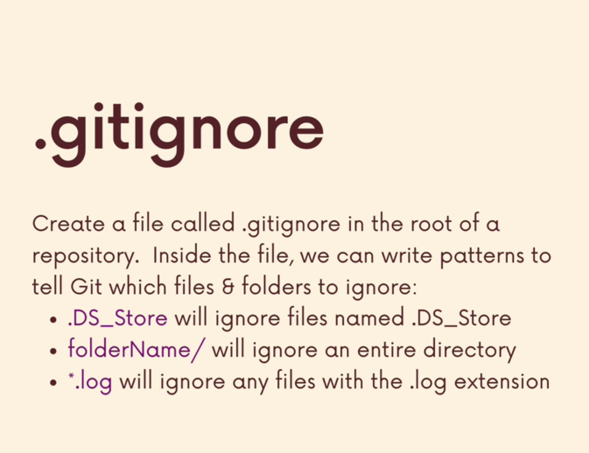

https://www.toptal.com/developers/gitignore

find out what ignore files should be put in .gitignore

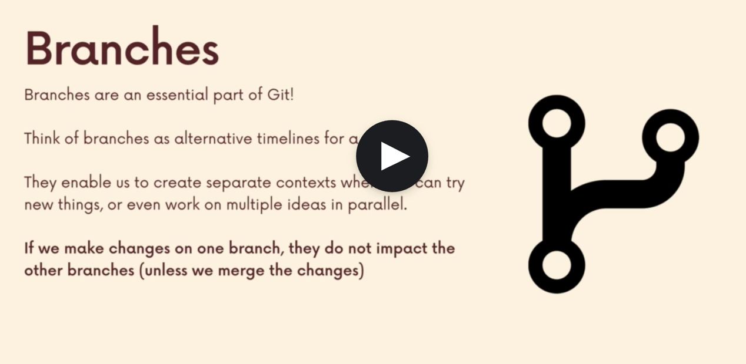

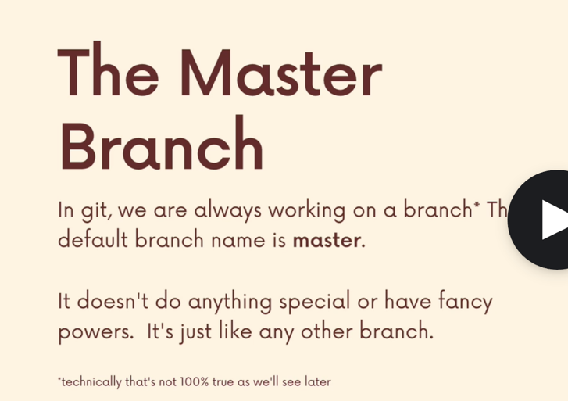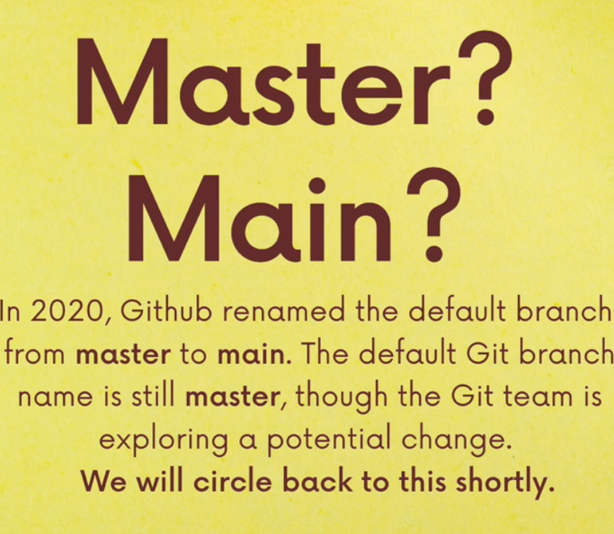

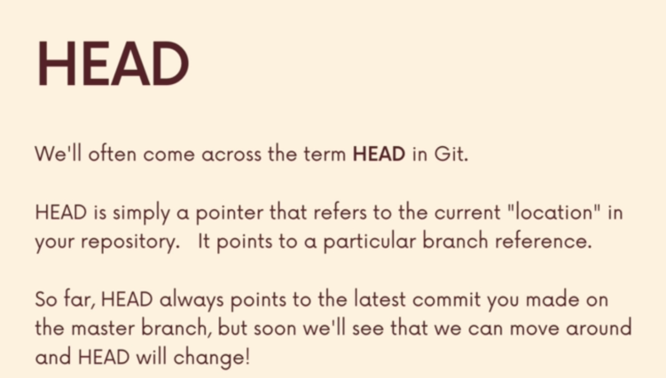

HEAD 是branch pointer

Switching branches by moving HEAD

**Git branch**

View current existing branches

*indicates the branch you are currently on.

**Git branch -v**

View existing branches with hash num and commit msg

**Git branch branchname**

Make a new branch based on the current HEAD

This just creates the branch, it does not switch you to that created branch.(THE HEAD stays the same)

**Git switch branchname / git checkout branchname (older way)**

Once created a new branch, use git switch to switch to it.

**Git switch -c branchname / git checkout -b**

Create a new branch and switch to it all in one go

= git branch + git switch

**Git commit -am “message”**

git add . and then git commit -m

We shout commit changes on a branch or stash them before switch to other branches, otherwise the changes will be lost.

**Git branch -d branchname / git branch -D (force delete)**

Delete a branch. 不能删除目前所在的branch, 要先switch to other branches.

**Git branch -m branchname**

Rename a branch. 只能rename 目前所在的branch的名字

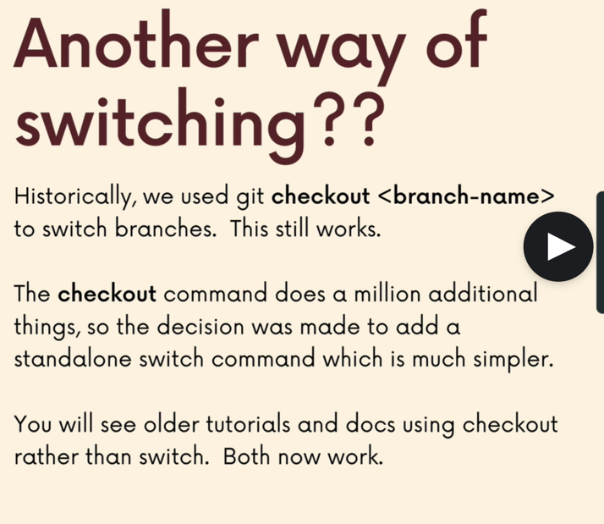

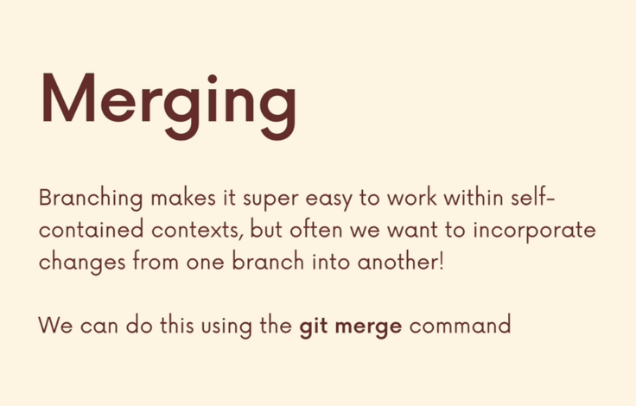

**We merge branches, not specific commits**

**We always merge to the current HEAD branch**

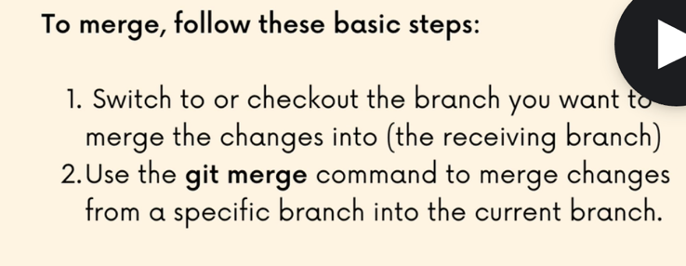

e.g want to merge bugfix branch to master

git switch master

git merge bugfix

**merge conflicts**

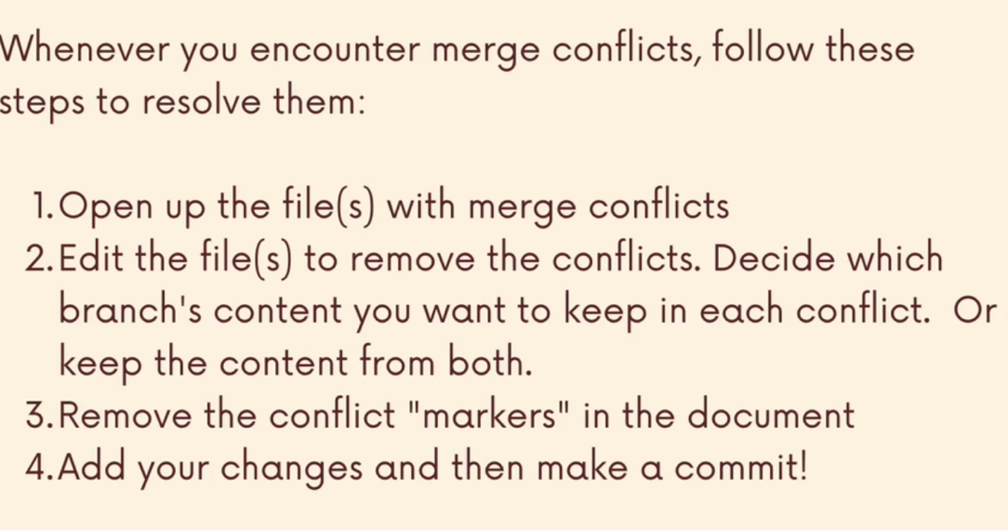

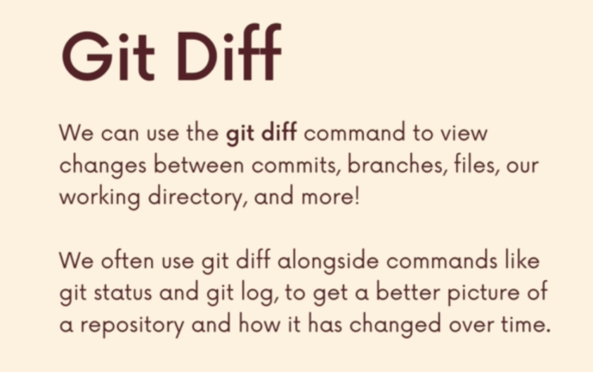

**Git diff**

**Showing only upstaged changes**

Git diff lists all the changes in our working directory that are different to the last commit. Comparing last commit and working directory (before stage).

Comparing the same file in different snapshots. Usually version a(---) is the file from last commit, version b (+++) is the working version (before staged).

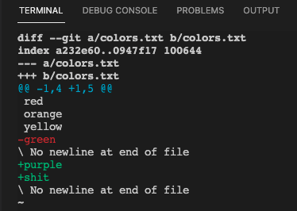

**Git diff head**

**Showing all, staged and unstaged changes**

与git diff不同的是，git diff只能显示unstage的（还没git add）的working directory与last commit 的不同。但git diff head 可以显示unstaged 和 staged与last commit的不同。

**Git diff –staged**

**Showing only staged changes**

Comparing last commit and staged changes.

“show me what will be included in my commit if I run git commit right now?”

**Git diff in specific file**

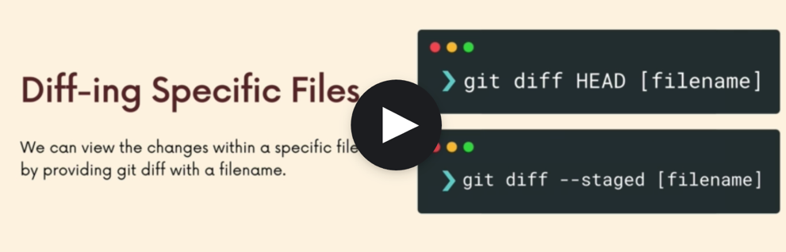

**Git diff changes across branches**

Git diff branch1..branch2 / git diff branch1 branch2

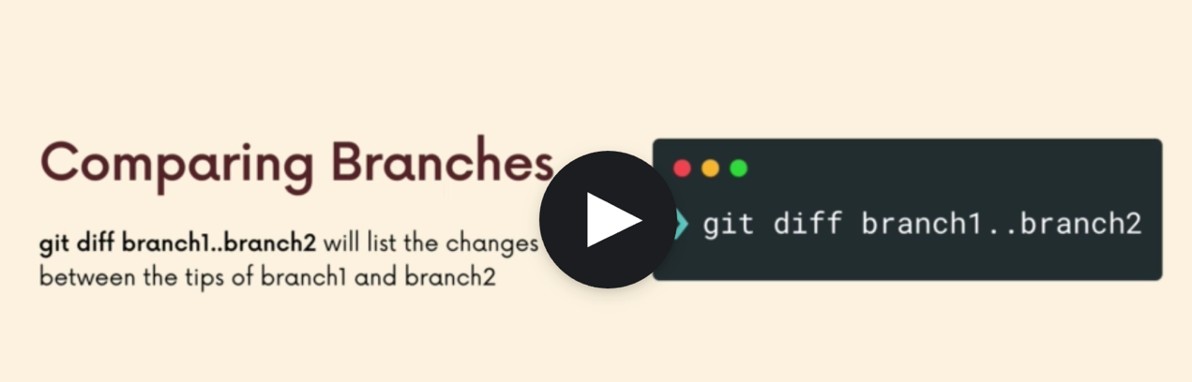

**Git diff compare commits**

Compare two commits with hash number (got from git log --oneline)

Eg. Git diff 2f8892f d48a0f3

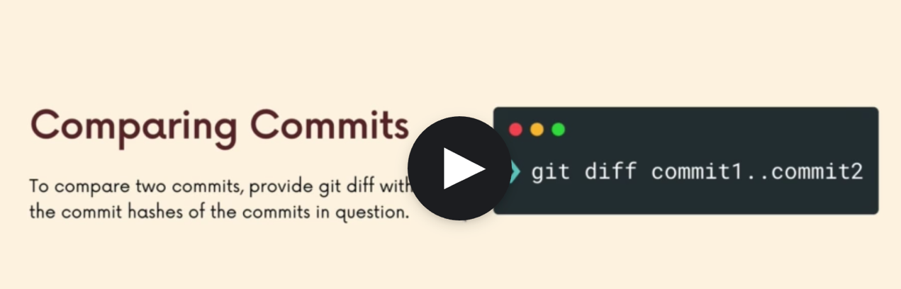

**Git stash**

Save changes without actually committing

Stashing uncommitted changes so that we can return to them later, without having to make unnecessary commits.

应用场景之一： have to switch to other branches when you are halfway done with a feature. Switch to other branch, the changes I done in feature branch will come with me, so I need to stash

Revert changes: 还原更改（返回上一个commit的状态）

**Git stash pop**

Remove the most recently stashed changes in your stash and reapply them to your working copy. (把changes从stash消除，并重新放回刚刚工作的branch的working directory)

**Git stash apply**

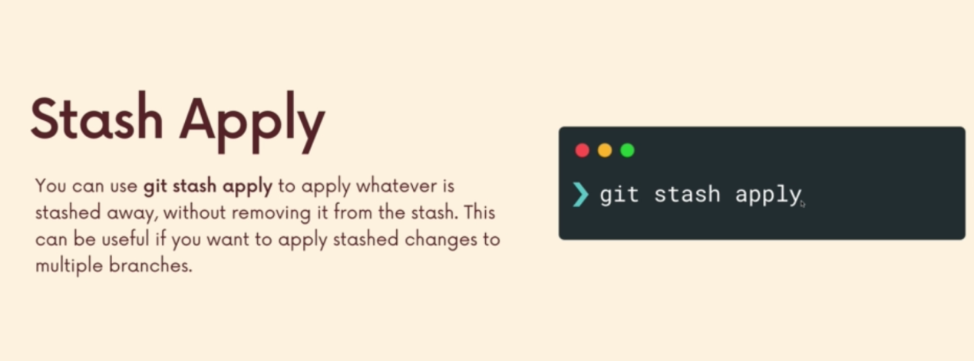

**Stashing multiple times**

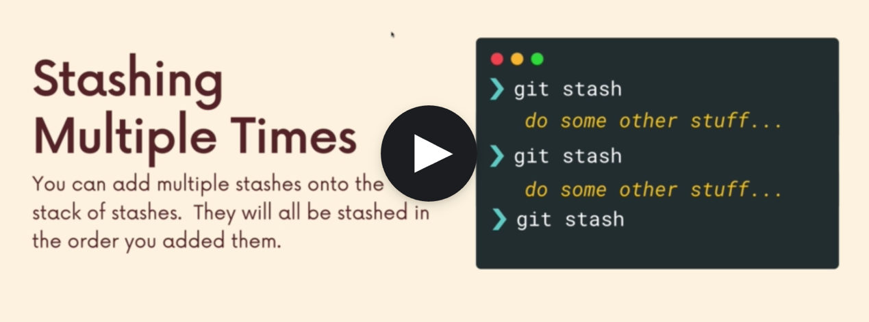

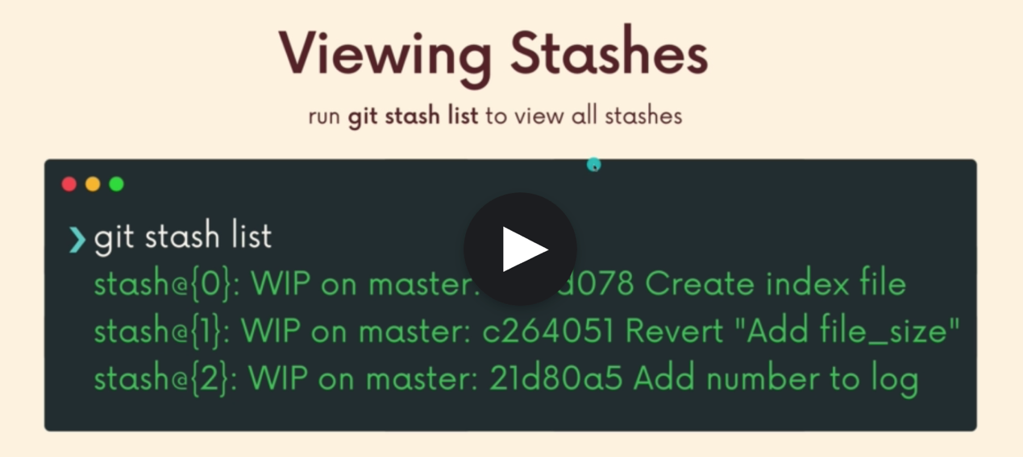

The very top of the list is the newest stash.

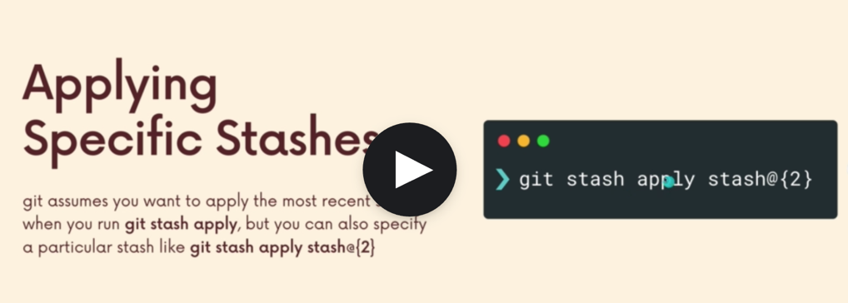

Stash id comes from git stash list

Delete a stash

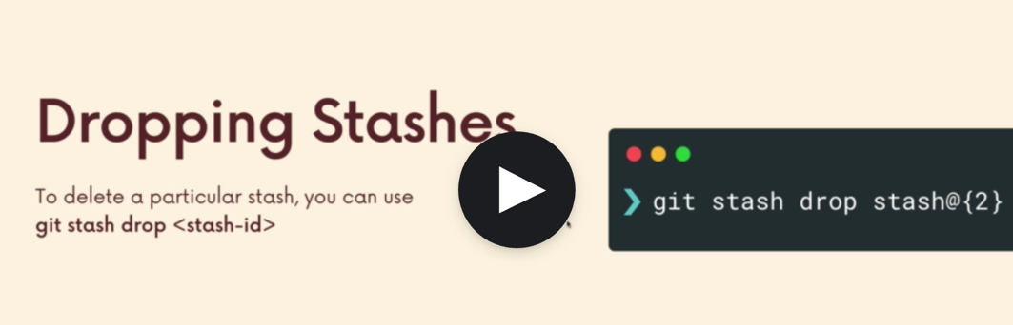

Delete all stashed

Git stash clear

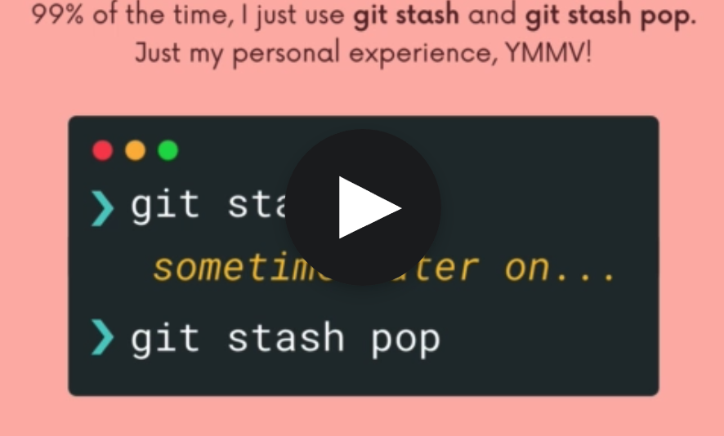

**time traveling**

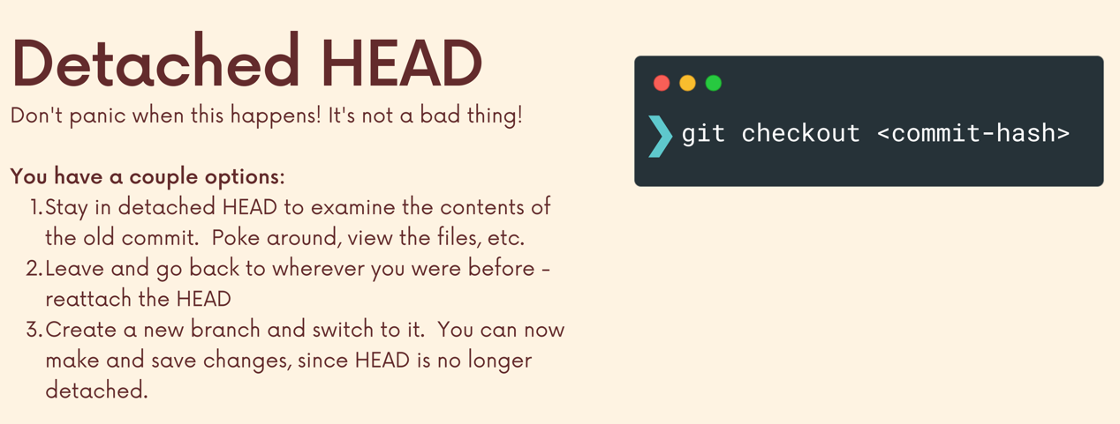**git checkout oldcommitHash**

Commit hash from git log –oneline

Option 1: stayed in detached head state, head points to old targeted commit. In head detached. state, I cant makes changes but can view files

Option 2: go back to where before doing git checkout commithash, git switch branchYouAre or git switch -

Option 3: create a new branch based upon the targeted commit(where the head is). Since. head is no longer detached after branch off, now I can make stuff and changes

**Git checkout head~1 / head~2/…**

One alternative to git checkout commitHash

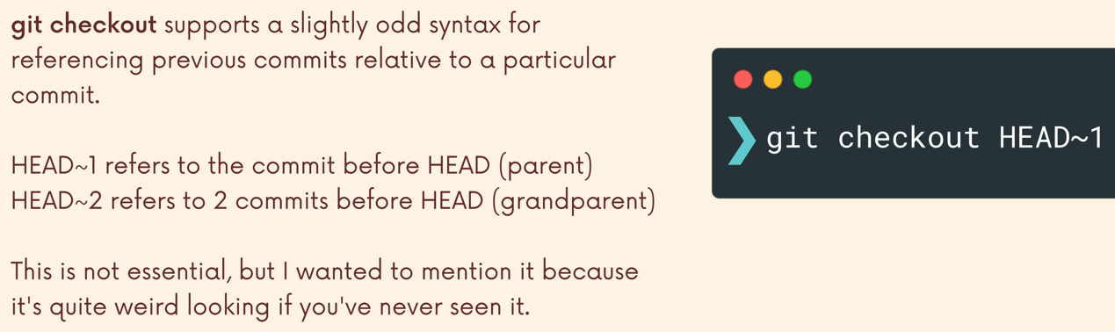

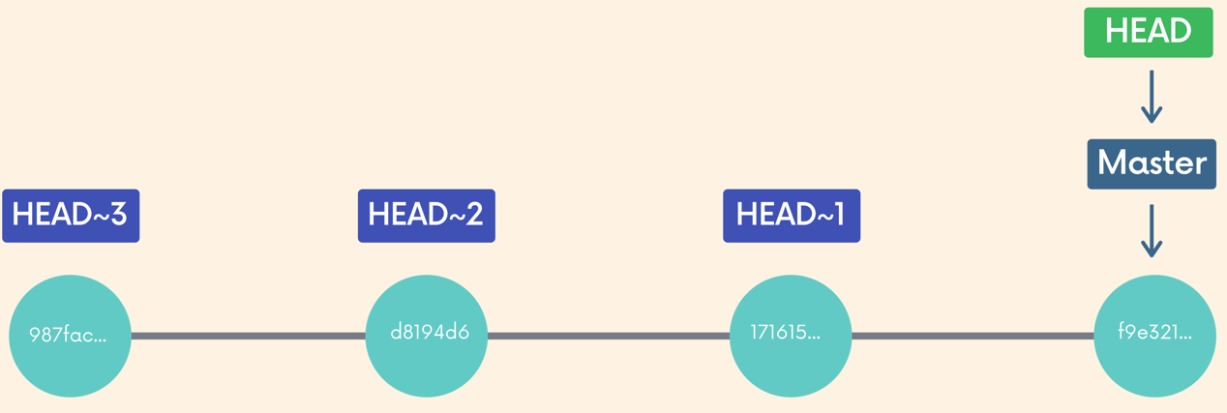

**Git checkout Head filename / git checkout – filename**

get Check-Out head and then a file name or multiple file names will reset those files,

contents back to whatever it looked like in your last commit

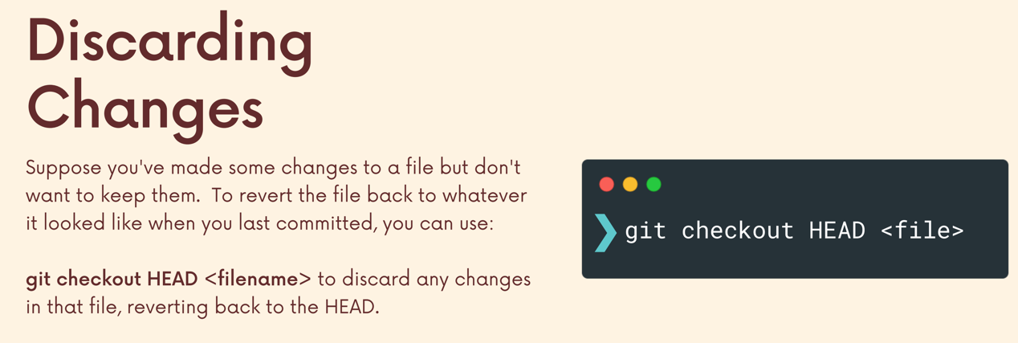

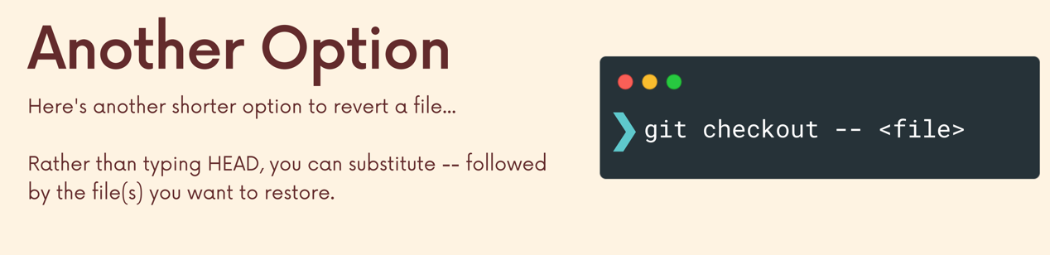

**Git restore**

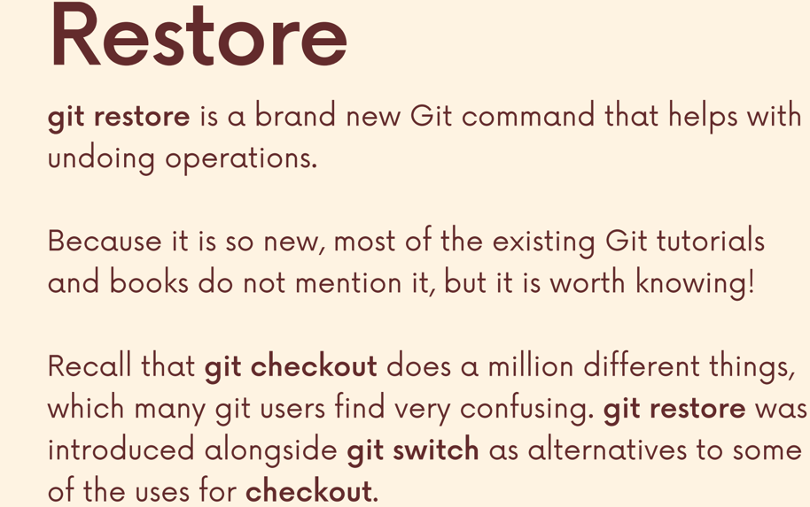

**Git restore filename**

Alternative to git checkout head filename / git checkout – filename

Go back to the last commit

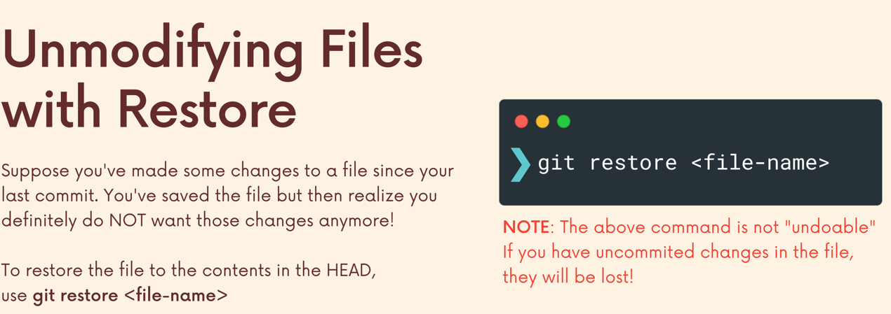

Git restore –source head~1 filename go back to head~1, the commit 1 before the head

Git restore –source head~2 filename go back to head~2, the commit 2 before the head

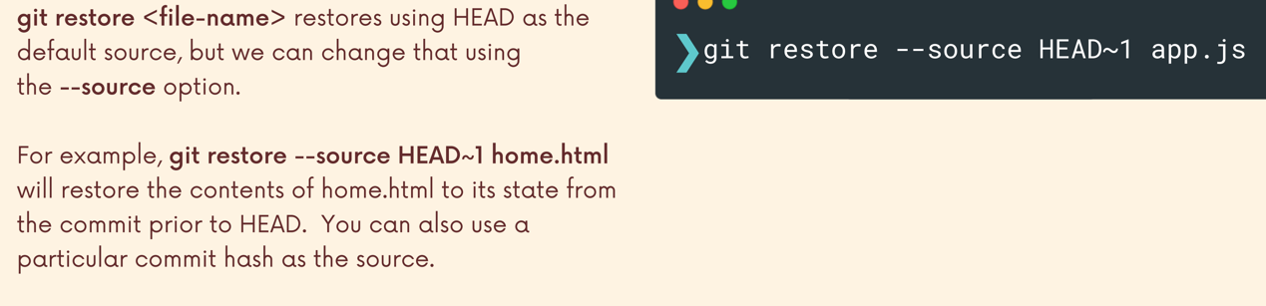

**Git restore –staged filename**

unstaging staged files

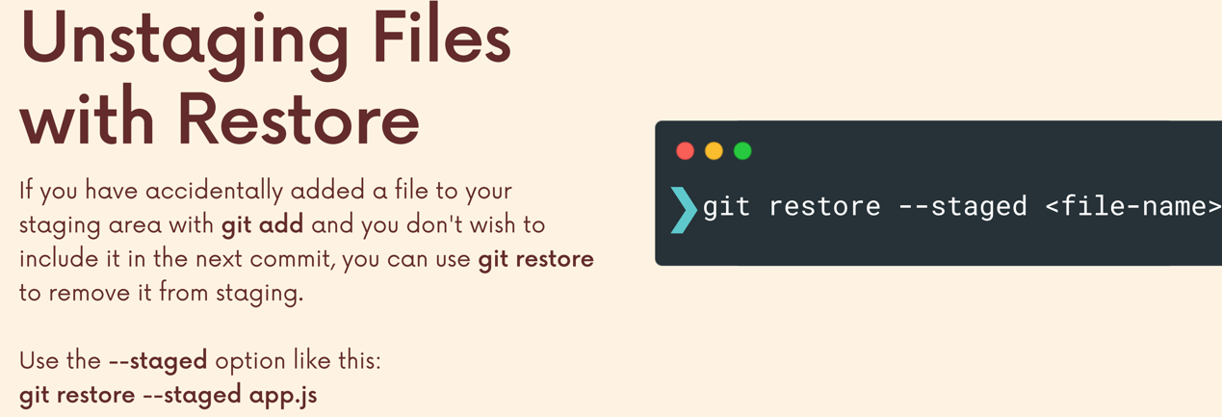

**Undoing stuff**

**Git reset commithash**

go back to the targeted commit, but changes in working directory still exist.

remove commits after the targeted commit, but doesn’t remove changes from working directory

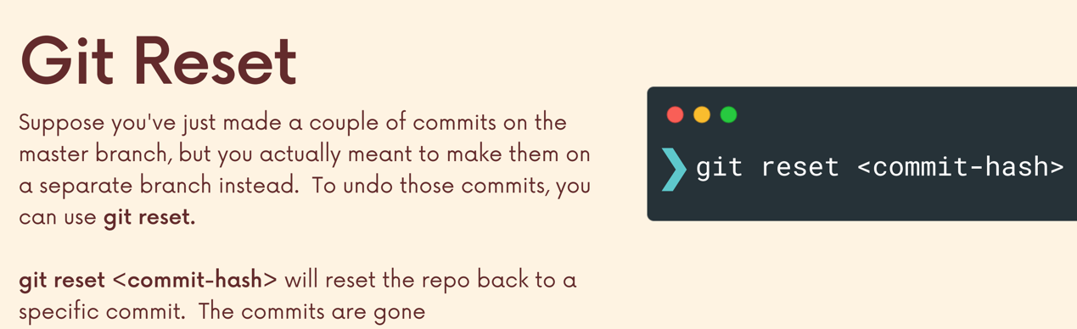

**Git reset –hard commithash**

Remove commits after the targeted commit, also remove changes from working directory

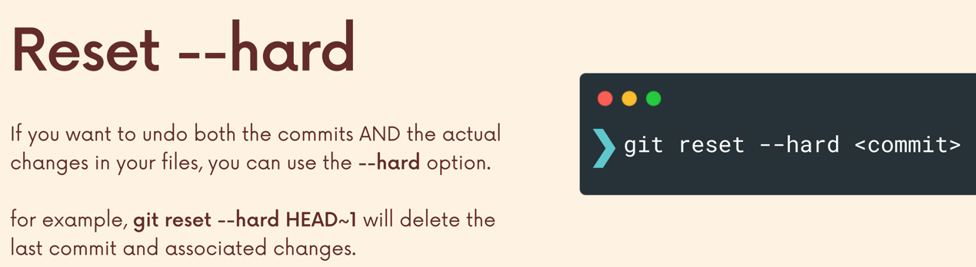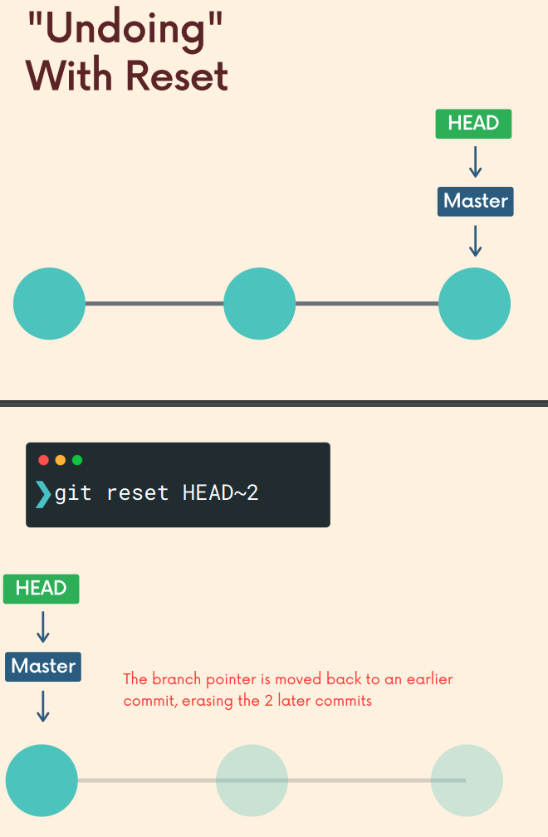

**Git revert**

Keep record of commits and undo the changes from targeted commit

Undo a commit by making a new commit that undoes the changes

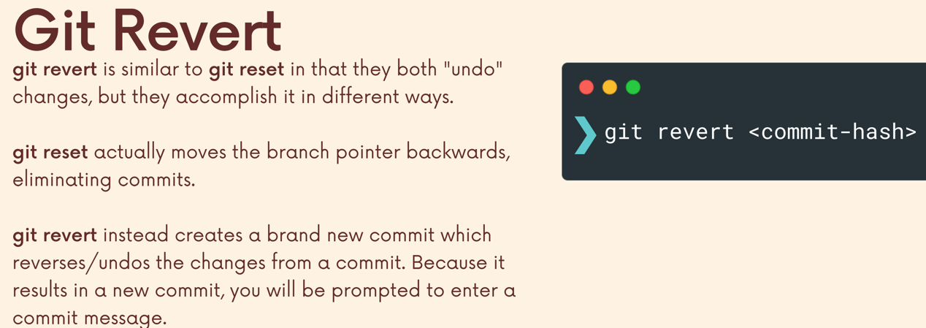

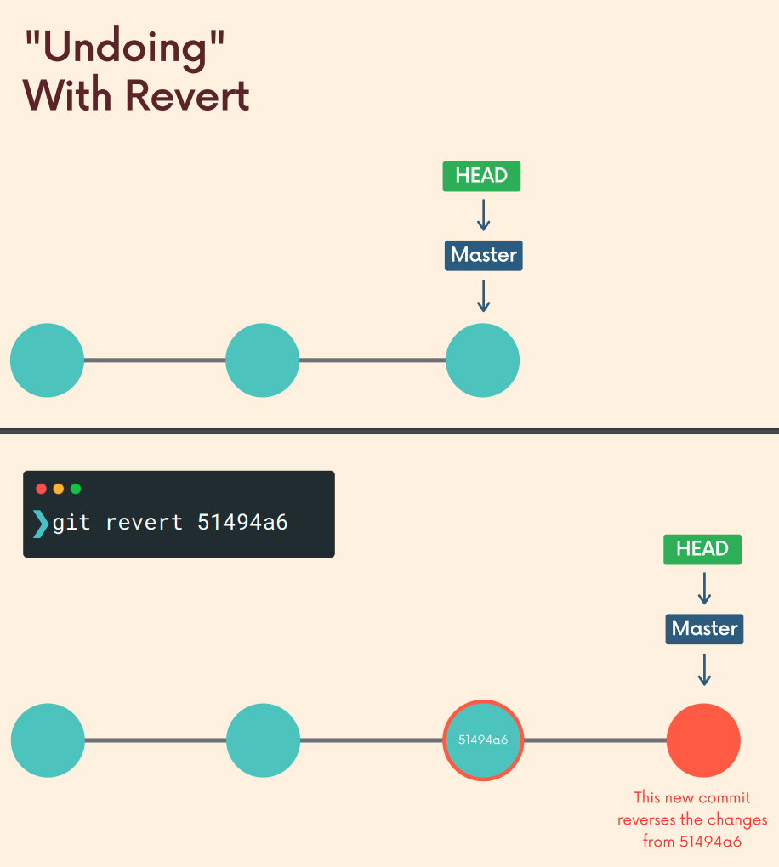

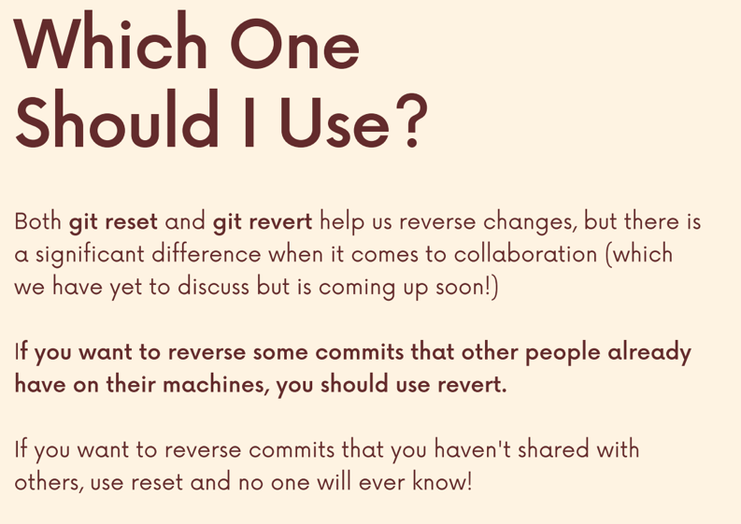

**Github**

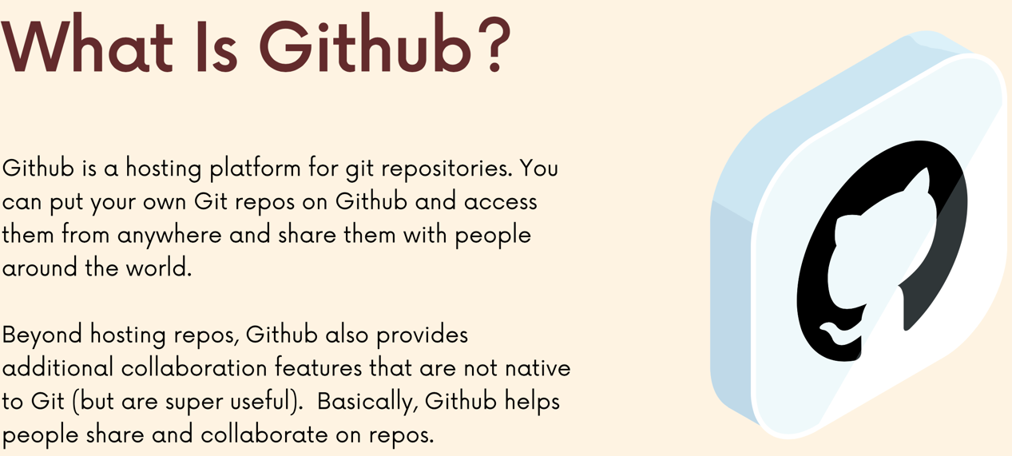

**Git clone url**

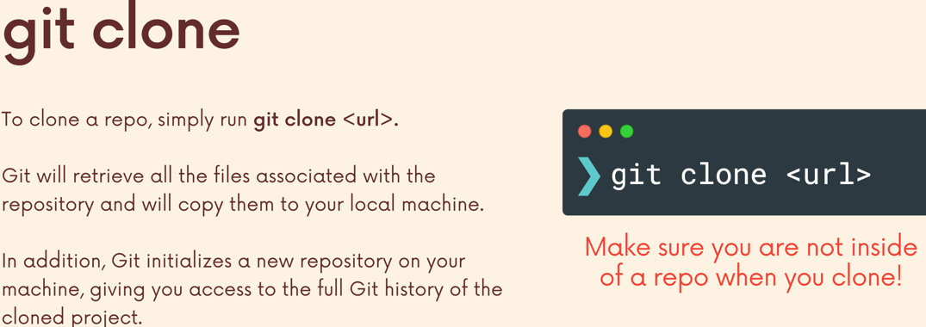

Git clone will get all commit history of the copied project to your local project.

**Configure SSH keys in Github**

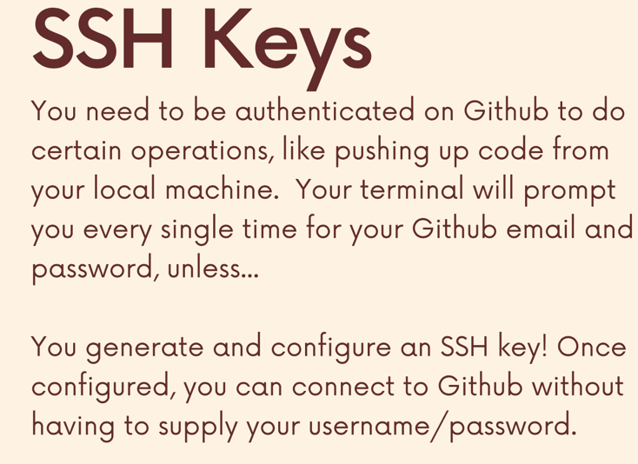

**Put code on Github**

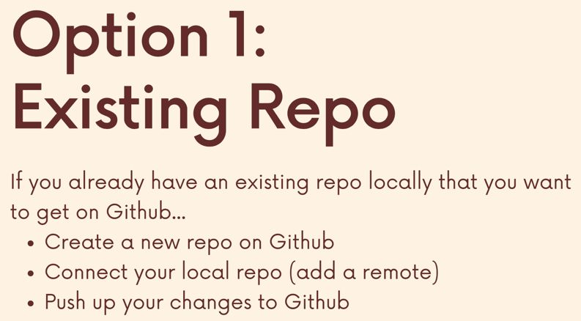

Step 1: create a new empty repo on GitHub

Step 2: tell your local repo about the GitHub repo (add a remote)

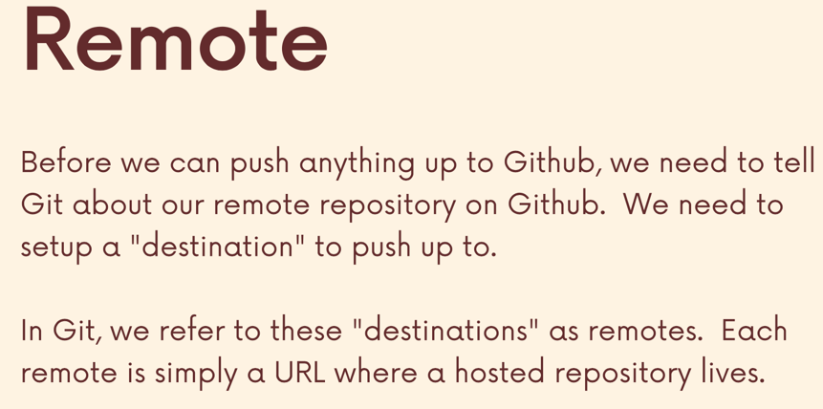

**Git remote-v**

To see if I have connected my local repo to github remote repo

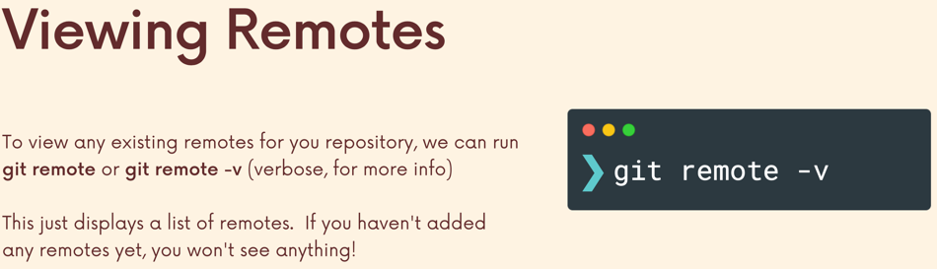

**Git remote add name url**

Name is the name of the url, the github repo url.

Name is “origin” by default

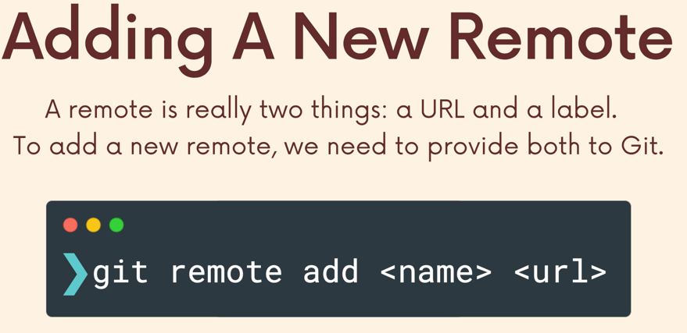

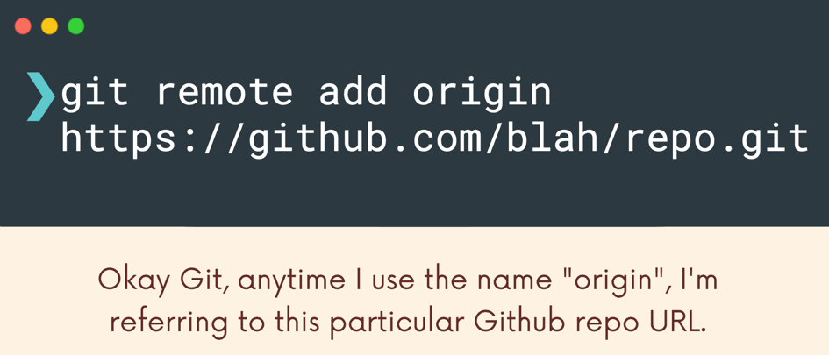

**What is origin**

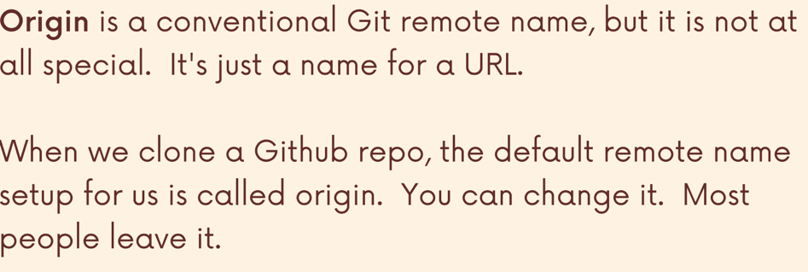

After git remote add, can use git remote -v to view remotes. The next step is to push from local repo

Step 3: push from local repo to the new GitHub repo

**Git push remote branch**

Push local branch to a remote (remote is the name of github repo url, by default is origin)

Before push our master branch, we need to rename our local master branch to main by git branch -m main. Because the default branch in github is main

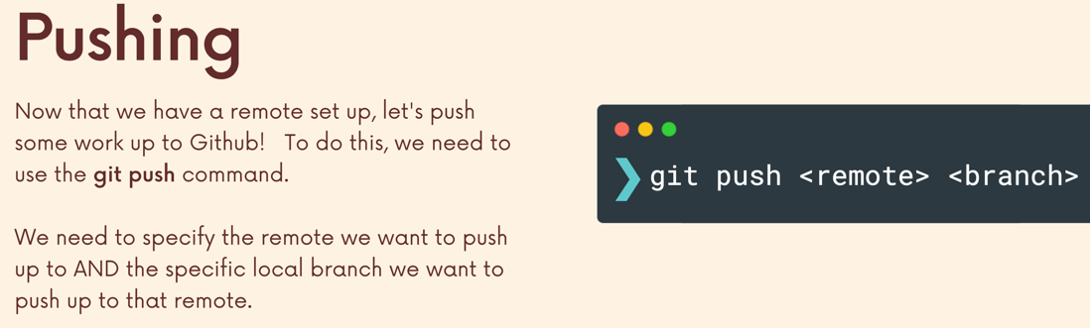

e.g **git push origin main**

push local main branch to github main branch at the origin url

**git push -u origin main**

用这个指令第一次push一个branch，那么local的这个branch就和github上面的这个branch连接了。所以接下来在这个branch上想再push这个branch, 直接git push 就可以了，不需要再git push origin main

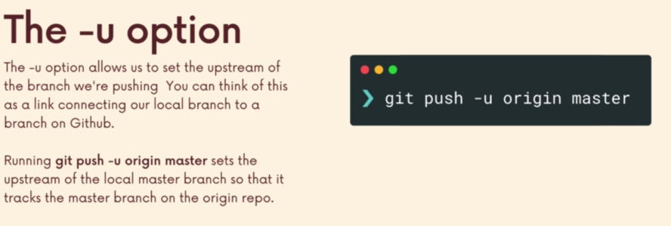

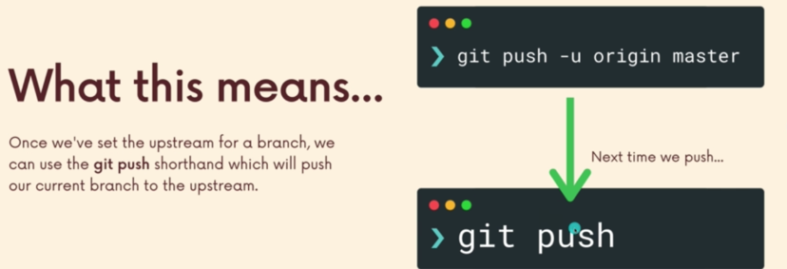

**git remote set-url origin newurl**

reset url

when local branch and remote branch has different name

git push origin local-branch:remote-branch

EASIER!

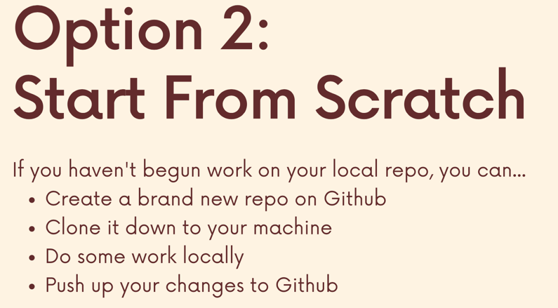

After clone repo down to local, the local repo is automatically connected to Github, so I don’t need to connect manually.

**Fetching & pulling**

Getting code down from Github to local.

After git clone, then we have:

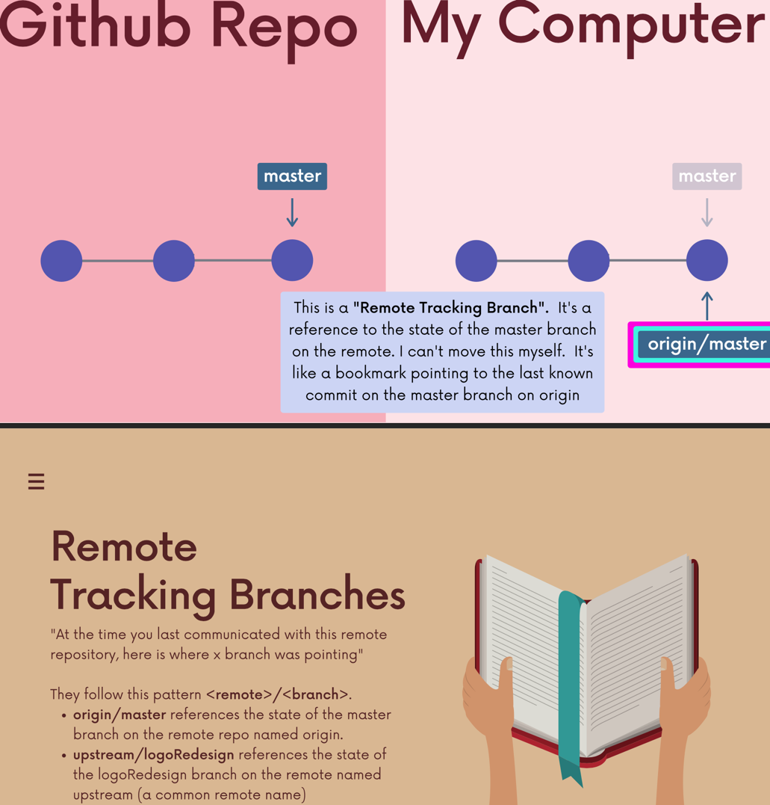

**Git branch -r**

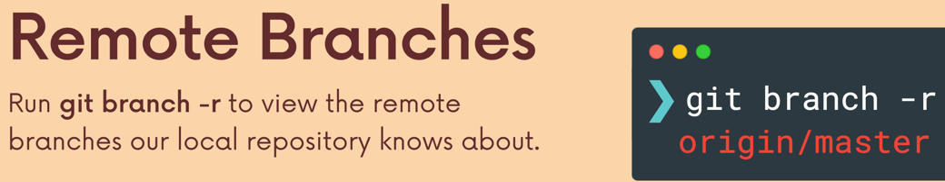

e.g origin/main means the main branch on origin (the Github repo url)

after clone a repo, assume I made two commits on local, the origin/main reference doesn’t move

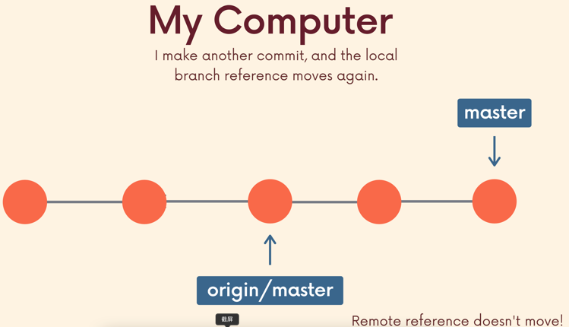

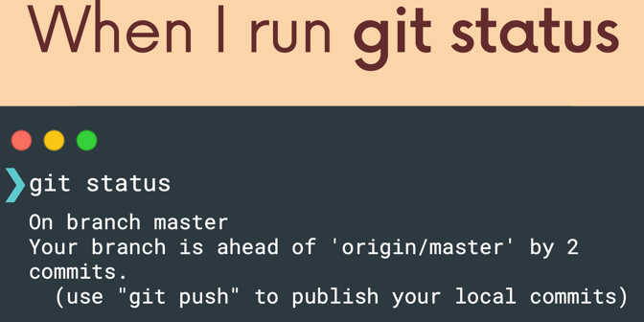

If I want to know what did this project look like when I first cloned this repo / last got an update from origin?

**Git checkout origin/main**

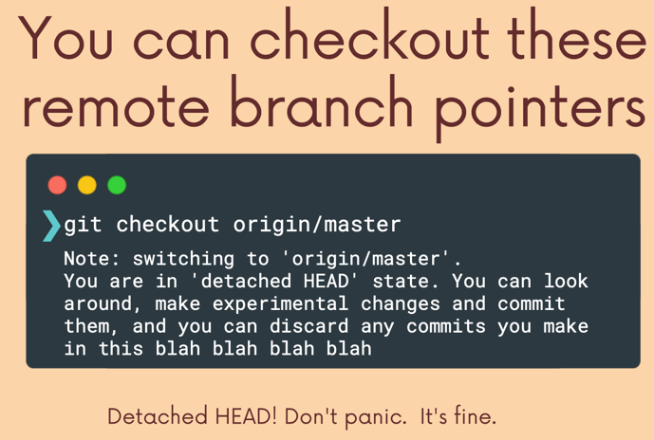

从GitHub上克隆了一个repo，这个repo有很多个branch。但是我克隆下来以后，只能更改default的main branch（git branch查找本地repo的branch只能找到main）, because by default, local main is already tracking origin/main.

假设github上面的这个repo有很多branches，其中一个是feature1, 我只能用git branch -r （git branch -r view the remote branches our local repo knows about） 找到它。 如果我用git checkout origin/feature1, 我会进入detached head状态，只能look around或者在origin/feature1的基础上branch off 一个新branch.

但是，我想有一个local branch called feature1, 然后我想将本地feature1 连接 origin/feature1. 这样才能在本地feature1上更改

**Git switch remote-branch / git checkout –track origin/remote-branch**

Create a new local branch from the remote branch of the same name.

e.g git switch feature1 makes a local feature1 branch and sets it up to track origin feature1

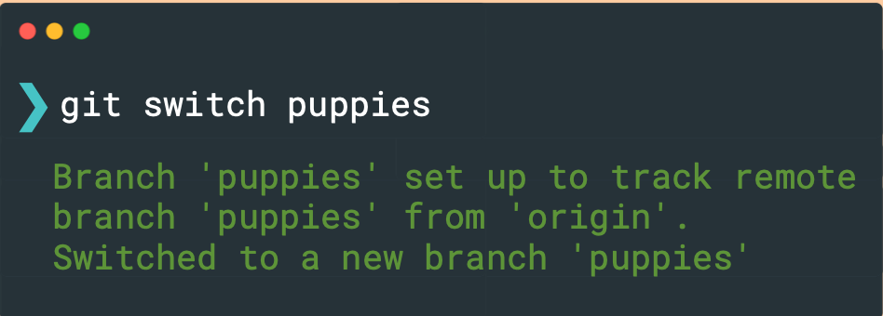

**Pull & fetch**

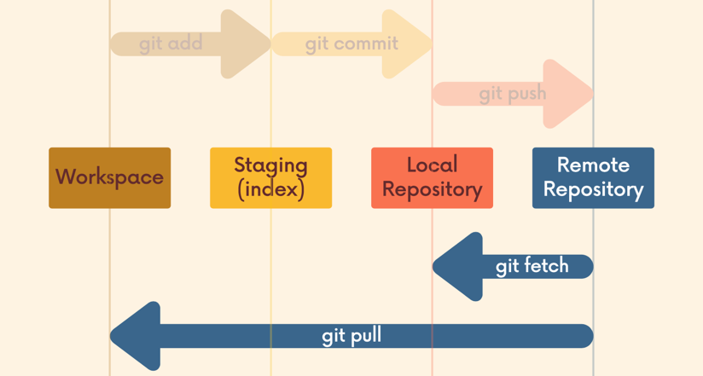

**Git fetch**

Download latest changes from github repo, but don’t integrate these changes to my current working directory

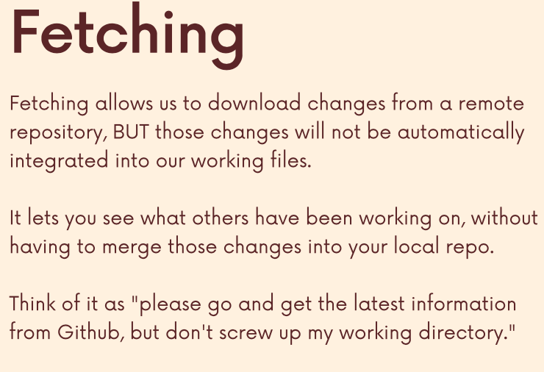

**Git fetch origin**

Fetch all changes from the origin remote repo (only remote tracking branches)

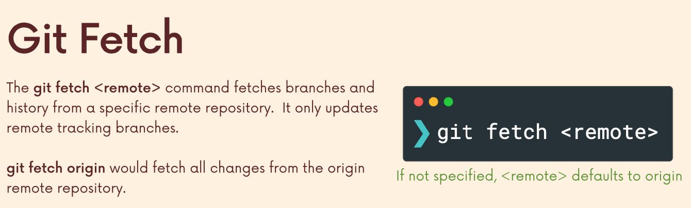

**Git fetch origin branchname**

Fetch a specific branch from origin remote

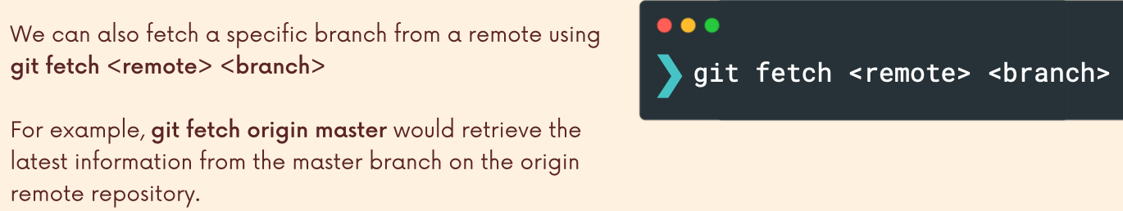

**应用场景**

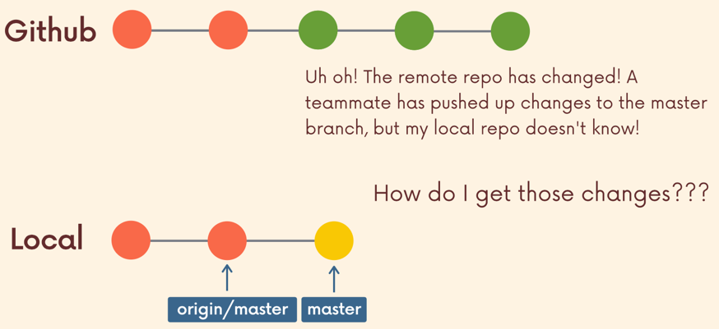

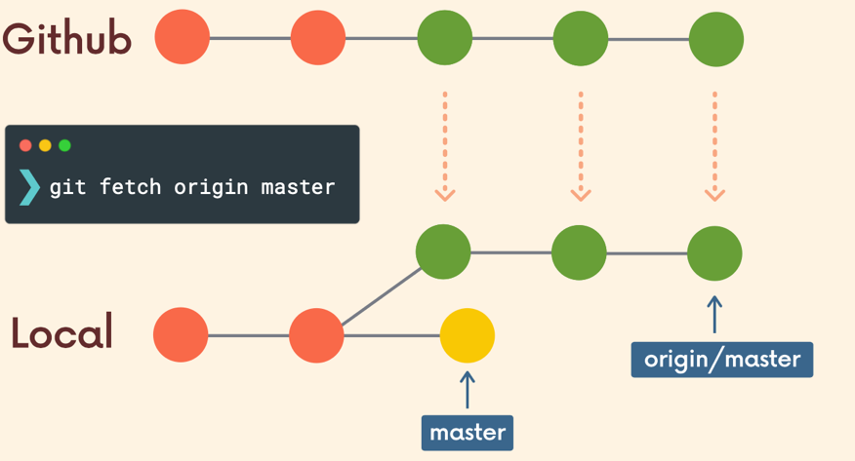

Download changes but I have not integrated changes into my working directory

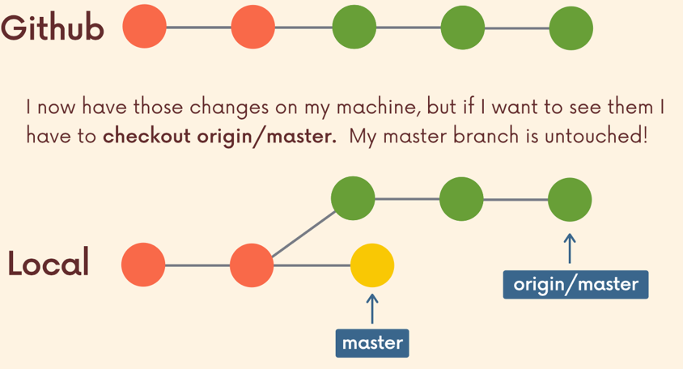

**Git pull**

Download latest changes from remote repo, and merge these changes to my working directory.

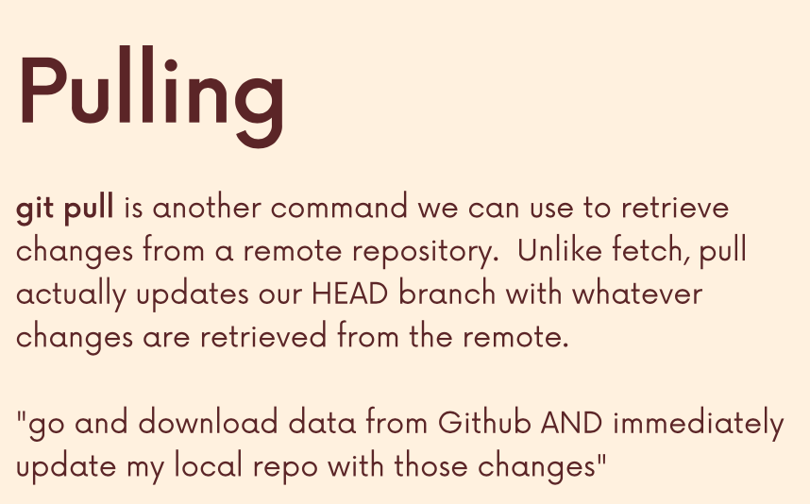

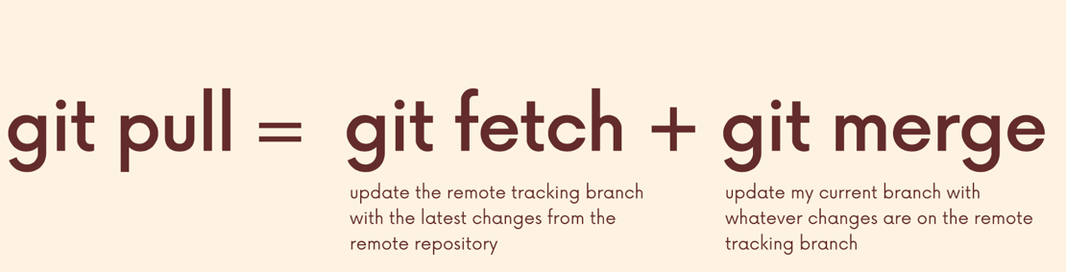

**Git pull origin branchname**

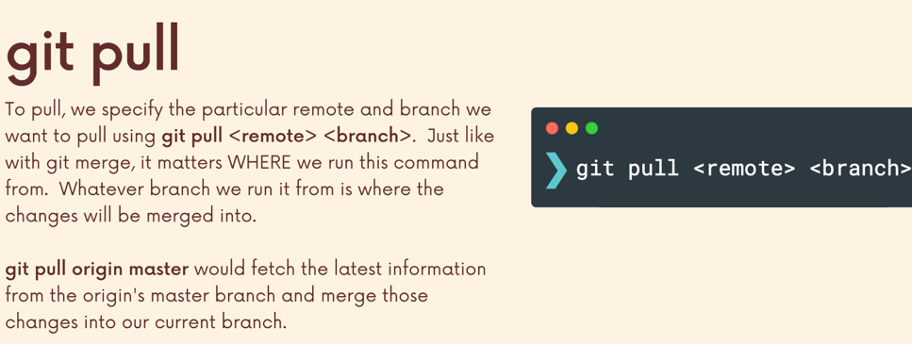

whatever branch I'm on, that is where the changes will be merged into where I'm pulling down to.

Git pull could result in merge conflicts

**Easier syntax of git pull origin branchname**

